Project Design Phase-II
Technology Stack – AI StudyBuddy Backend

Date | 23 September 2026
Team ID | SWTID-2026-2773
Project Name | AI StudyBuddy
Maximum Marks
Technical Architecture: Node.js/Express REST API + MongoDB/Mongoose + JWT/bcryptjs + Multer + Gemini 2.5 Flash.
The architecture of AI StudyBuddy is designed as a robust, scalable, and secure AI-powered backend system. The backend is built using Node.js and Express to handle REST API routing, request validation, and middleware operations. JWT (JSON Web Tokens) and bcryptjs ensure secure user authentication and role-based access control. For processing uploaded documents (.pdf, .txt, .md), Multer and Node's file system (fs) handle temporary file storage and text extraction. The extracted content is sent to Google's Gemini 2.5 Flash API to dynamically generate summaries, flashcards, quizzes, and personalized study plans. All user data, uploaded material metadata, and generated study content are persistently stored in MongoDB using Mongoose ORM.
Example: AI-Powered Study Material Processing and Learning Content Generation System.
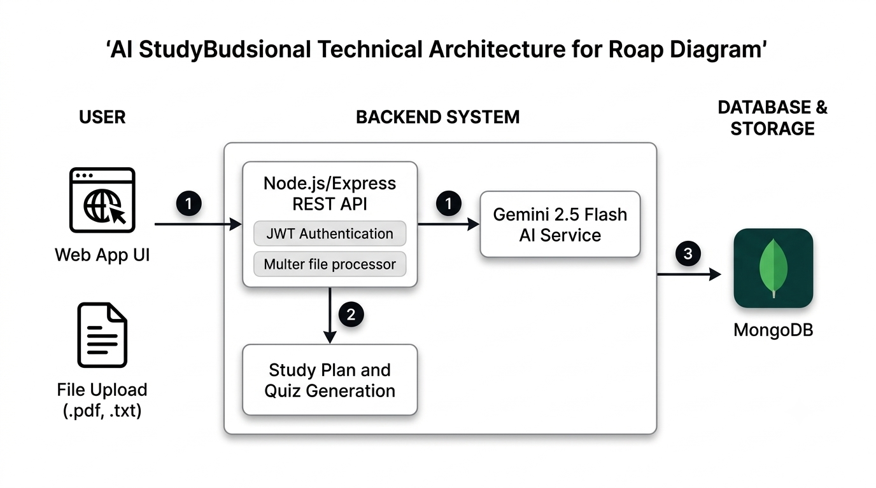
Reference: https://developer.ibm.com/patterns/ai-powered-backend-system-for-order-processing-during-pandemics/
Table-1: Components & Technologies
S.No | Component | Description | Technology
1 | User Interface | Client consumes the REST API; no frontend code is supplied. | Web UI / React.js / Mobile App
2 | Application Logic | REST API routes, controllers, and middleware. | Node.js + Express
3 | Database | Stores users, study materials, and generated learning content. | MongoDB + Mongoose
4 | File Upload | Temporary upload and text reading for .txt, .md, and .pdf files. | Multer + Node fs module
5 | AI Service | Generates summaries, flashcards, quizzes, and study plans. | Gemini 2.5 Flash
6 | Authentication | Password hashing, JWT tokens, and role-based access checks. | bcryptjs + jsonwebtoken
7 | Infrastructure | Node.js server with a configurable port. | Local server / Node.js runtime
3. Table-2: Application Characteristics
S.No | Characteristics | Description | Technology Used
1 | Open-Source Frameworks | Express, Mongoose, Multer, and Node.js packages. | Node.js ecosystem (npm packages)
2 | Security Implementations | JWT authentication, bcrypt password hashing, role-based access, and protected material access. | jsonwebtoken, bcryptjs
3 | Scalable Architecture | Modular routes, controllers, models, middleware, and utilities. | Express modular structure
4 | Availability | Root health-check endpoint confirms API status. | Express GET / endpoint
5 | Performance | AI generation is triggered on-demand; list endpoint excludes large content fields. | MongoDB + Express async handling
References / Useful Links:
- C4 Model Architecture:
https://c4model.com/
DOCX
- IBM AI Backend System Pattern:
https://developer.ibm.com/patterns/ai-powered-backend-system-for-order-processing-during-pandemics/
DOCX
- IBM Cloud Architecture:
https://www.ibm.com/cloud/architecture
DOCX
- AWS Architecture Center:
https://aws.amazon.com/architecture
DOCX
- Drawing Technical Diagrams Guide:
https://medium.com/the-internal-startup/how-to-draw-useful-technical-architecture-diagrams-2d20c9fda90d
DOCX
- Google Gemini API Documentation:
https://ai.google.dev/docs

